TDC, 1st Year, 2nd Sem, Paper-2016

Mala Moni Kalita, Asstt. Prof.
BURGESS AND HOYT THEORIES OF INTERNAL STRUCTURE OF TOWN
Each city is unique in respect of the detailed pattern of its internal landuse, yet there is a considerable degree of repetition in the broad geographical arrangement of various categories of urban landuse from one city to another. Even a casual inspection of cities reveals that different areas of the city have been given for different landuses. But in most of the city a generalized pattern of landuse can be observed which reflects the role of certain controlling factors like the land values, accessibility and the history of urban growth. On the basis of some generalized pattern of urban landuse a number of theories have been propounded which attempts to generalize about the arrangement of landuse regions within a city. These theories are also known as ‘models of internal structure’ of towns and also urban growth theories. In this regard important theories are as follows:
1. Concentric zone theory by Burgess
2. Sector theory by Hoyt
3. Multiple Nuclei theory by Harris and Ullman
4. Fused Growth theory by Garrison
5. Work Home Concept by Rame Gowda
The Burgess model
Geographers have put together models of land use to show how a 'typical' city is laid out. One of the most famous of these is the Burgess or concentric zone model.
This model is based on the idea that land values are highest in the centre of a town or city. This is because competition is high in the central parts of the settlement. This leads to high-rise, high-density buildings being found near the Central Business District (CBD), with low-density, sparse developments on the edge of the town or city.
The Concentric zone model, or Burgess model is a model to explain how a settlement, such as a city, will grow. It was developed by Ernest W. Burgess between 1925 and 1929. The model was the first to explain why certain groups of people lived in certain areas of the city.
The urban planning structure of the Burgess model
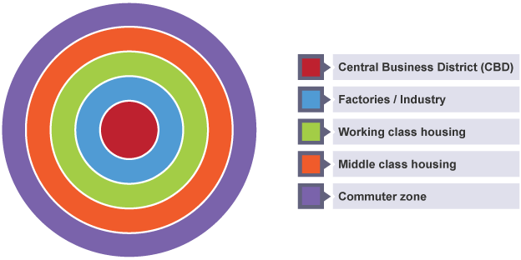
Burgess model
However, there are limits to the Burgess model:
The model is now quite old and was developed before the advent of mass car ownership.
New working and housing trends have emerged since the model was developed. Many people now choose to live and work outside the city on the urban fringe - a phenomenon that is not reflected in the Burgess model.
Every city is different - there is no such thing as a typical city.
The Hoyt model
Hoyt model, is a model of urban land use proposed in 1939 by land economist Homer Hoyt. It is a modification of the concentric zone model of city development. The benefits of the application of this model include the fact it allows for an outward progression of growth.
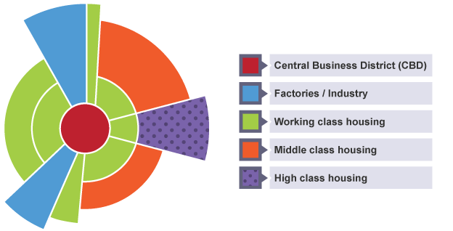
Hoyt model
Hoyt model is based on the circles on the Burgess model, but adds sectors of similar land uses concentrated in parts of the city. Notice how some zones, e.g. the factories/industry zone, radiate out from the CBD. This is probably following the line of a main road or a railway.
The major differences between the Burgess and the Hoyt models is the fact that the Burgess model is based around a simple circle-based area organizational, where the centre circle is the CBD, then around the CBD are 'rings' of other zones. The only similarity is that the CBD is located in the middle.

